Using Arduino IDE with NodeRed to Database

Step1: Setting up the NodeRed

IBM account – nag.s@digiotai.com

First go to [mybluemix.net](https://cloud.ibm.com/docs) then the following tab appears.

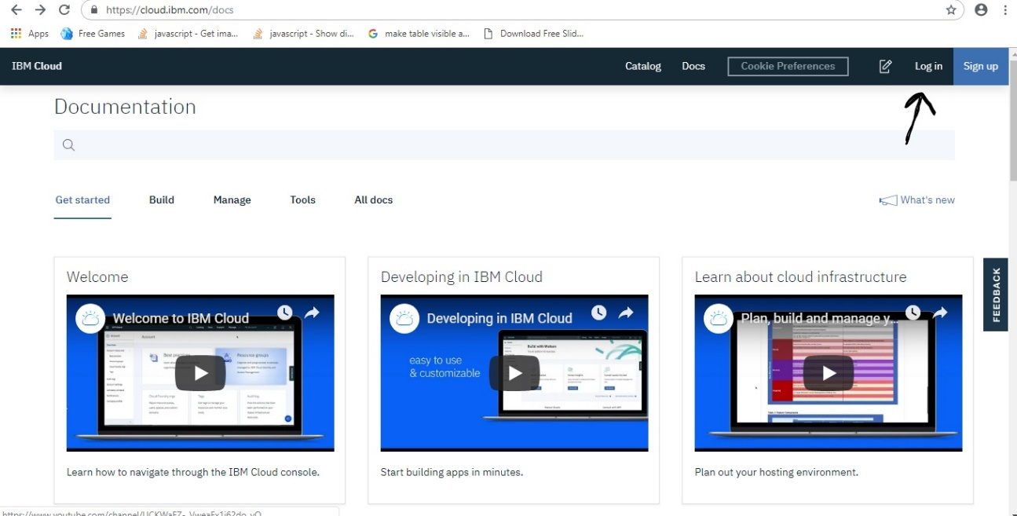

Then login in to it. After login go to your NodeRed Editor and connect the nodes as follows: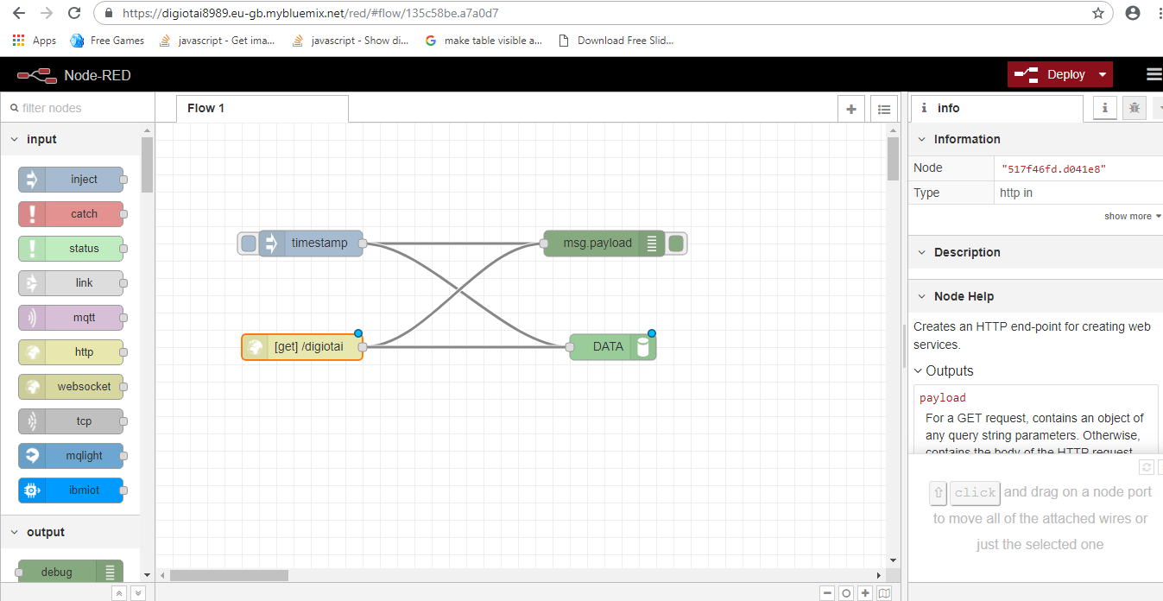

Now you want to configure the dash dB node you want to create a db2 database as shown below

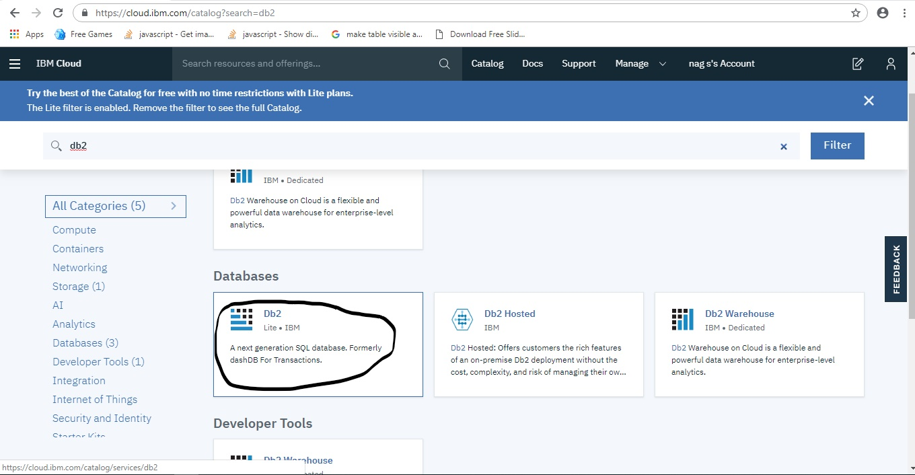

Now click on Db2 which is marked above. The following tab appears

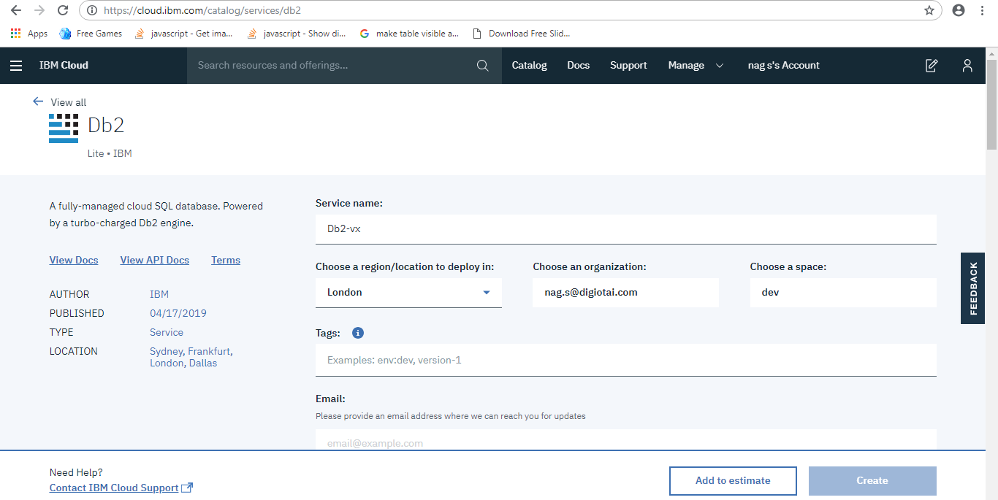

Now click on create to create a database.

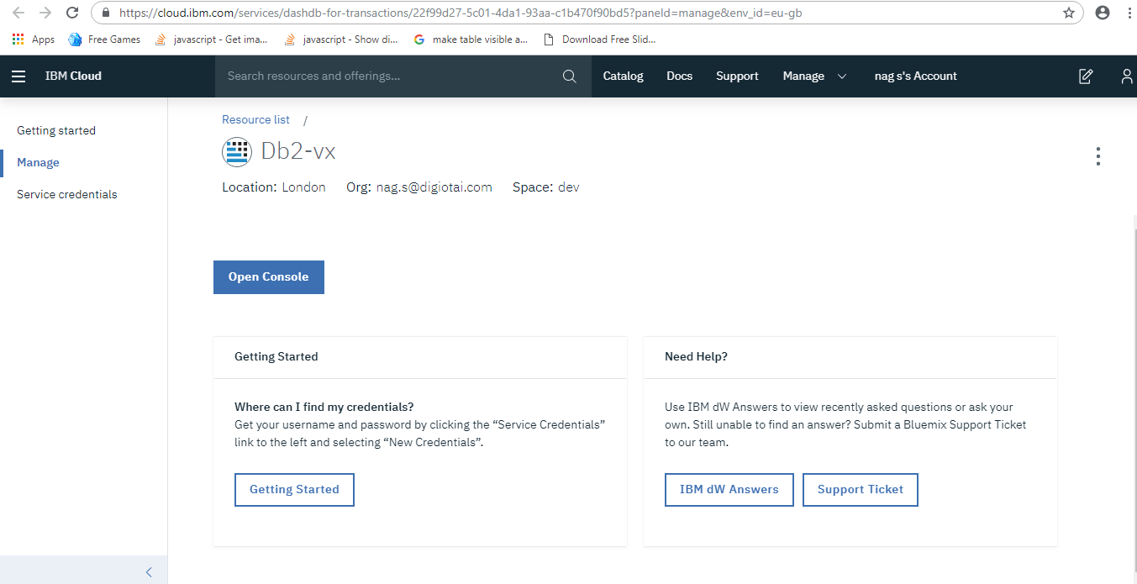

Now go to service credentials and create a new one

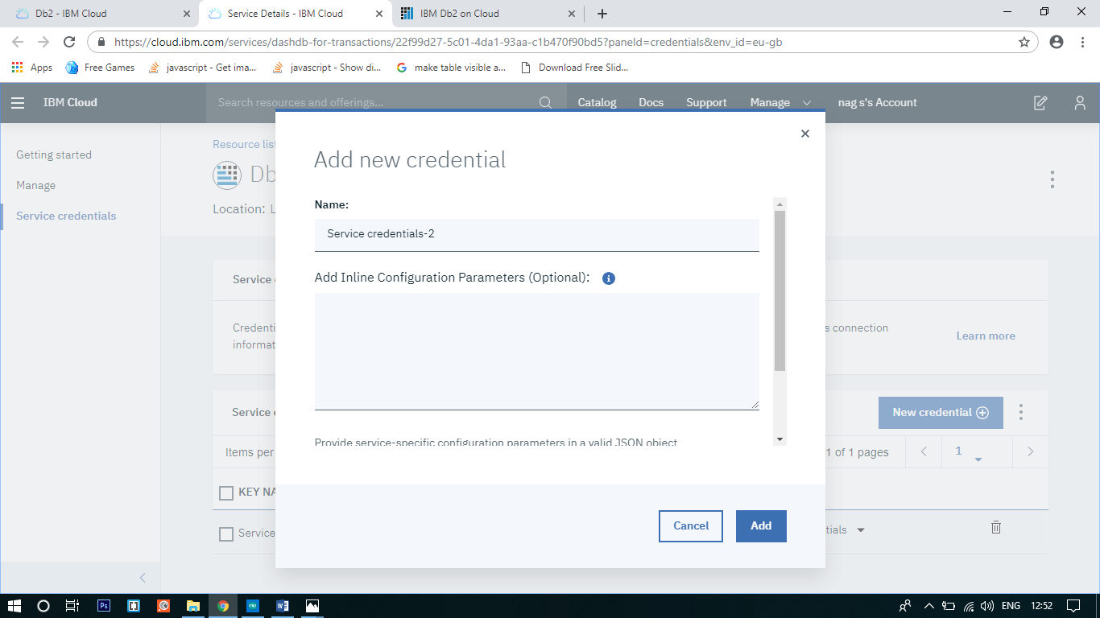

Now click on Add button to create it.

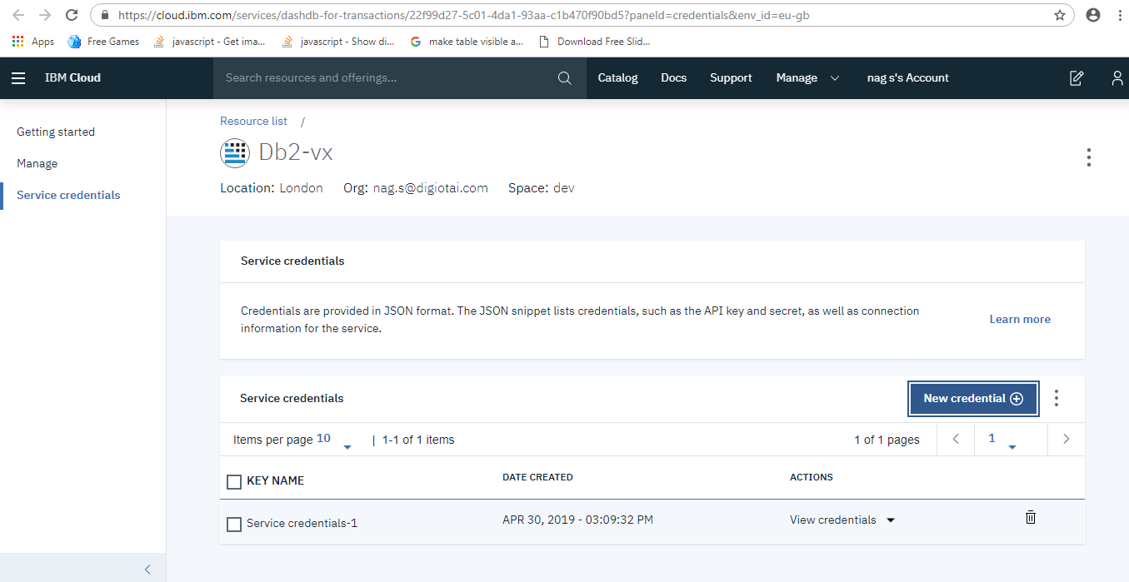

Now click on view credentials then u will able to see the required credentials.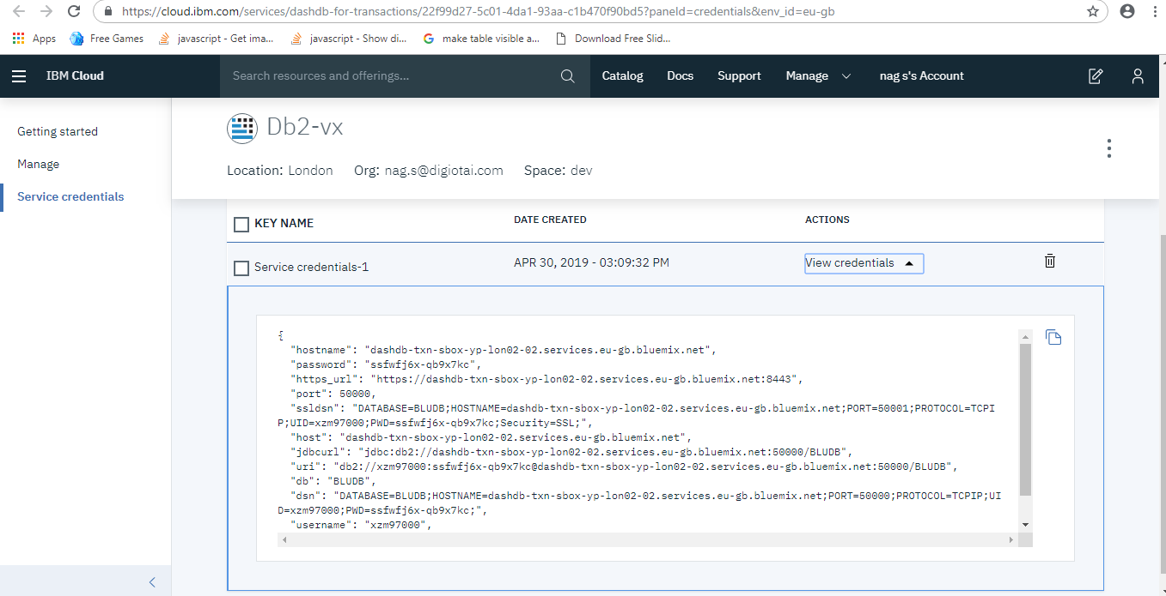

Now go to Manage-> Open console and click on menu slider at top left and click on “Run sql” and type the following.

create table DATA (TEMP VARCHAR(255), HUM VARCHAR(255));

After enter the above code click on run button.

Then go Explore in the menu slider.

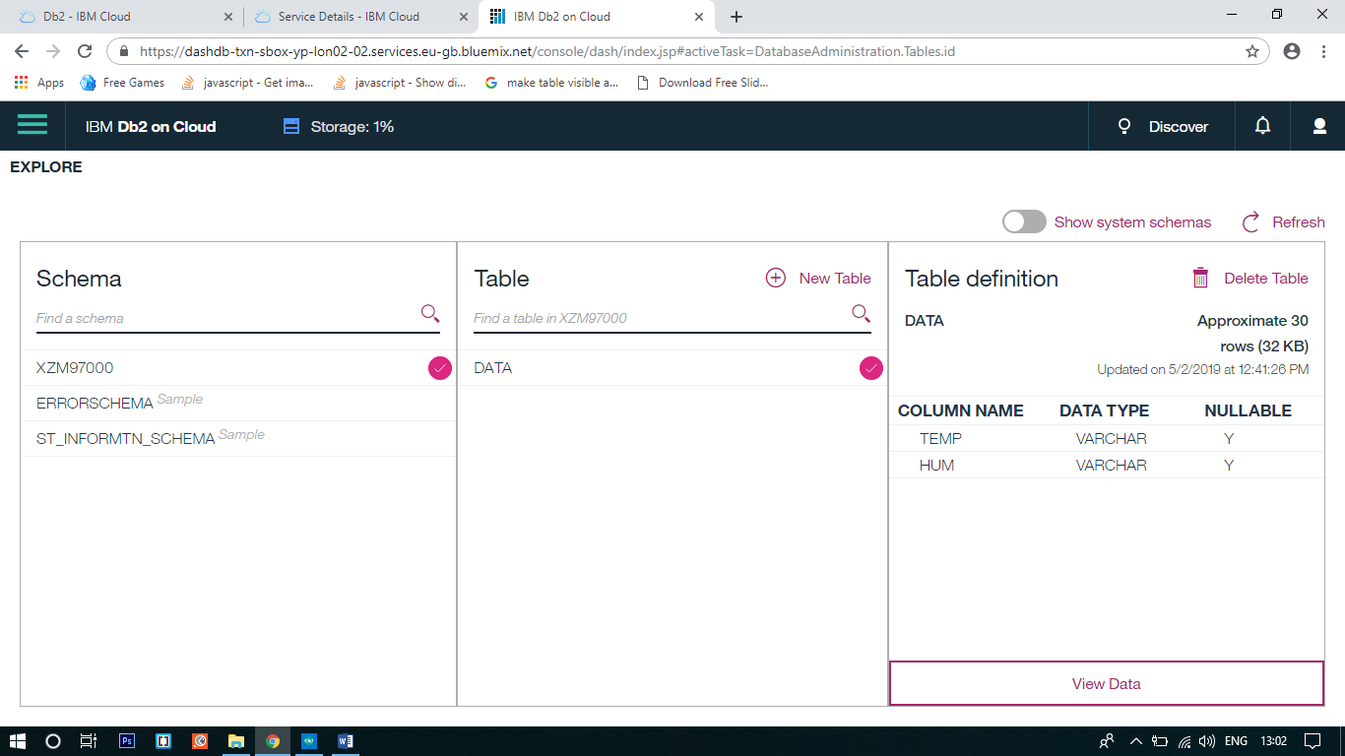

Now open the NodeRed Editor and go to Db2 database and edit the server and fill the required details which is present in the service credentials then update it.

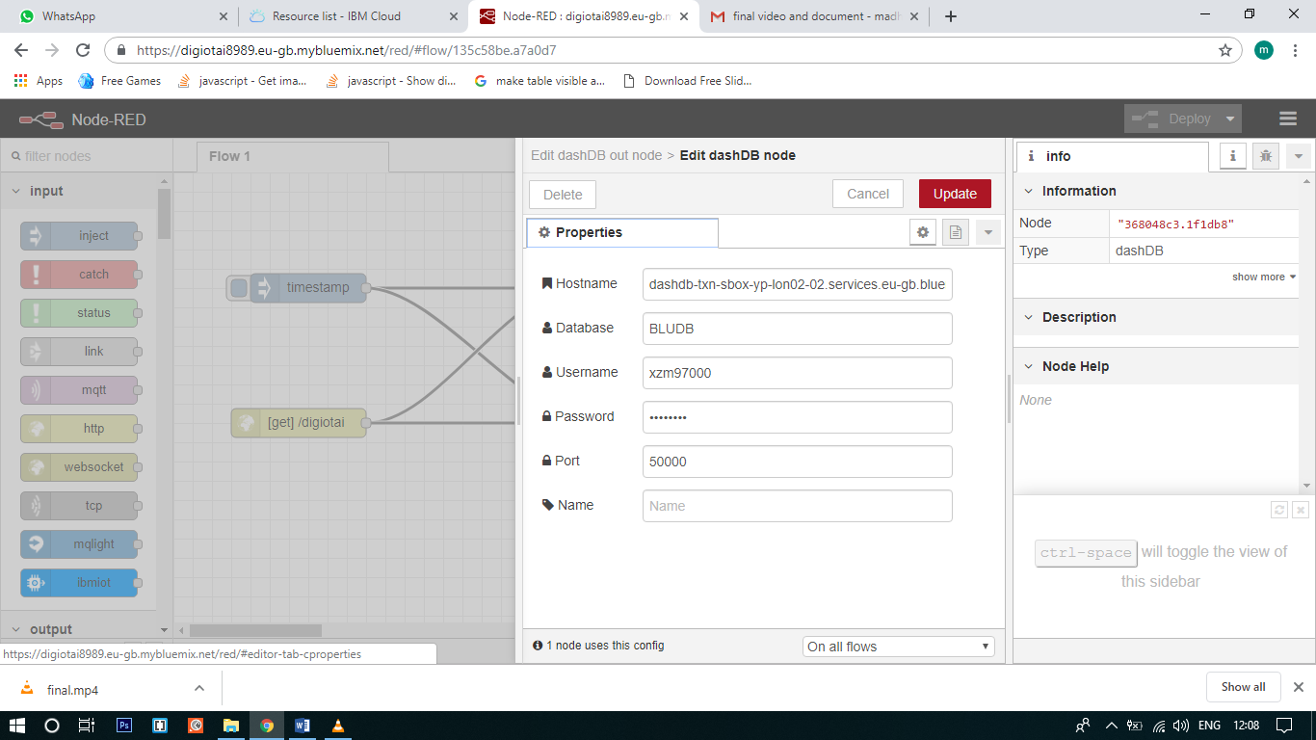

After updating the server with service credentials don’t forget to hit the Deploy button.

Then open the Aurduino IDE and paste the code in it.

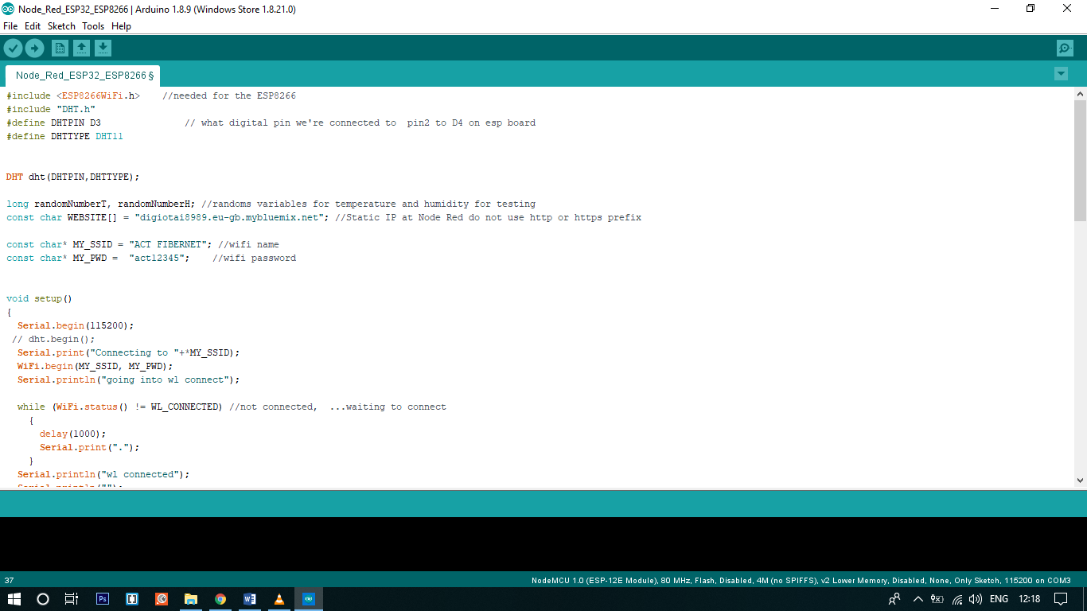

Connect the IoT device to your machine and compile the code.

Then open the serial monitor and see the results.

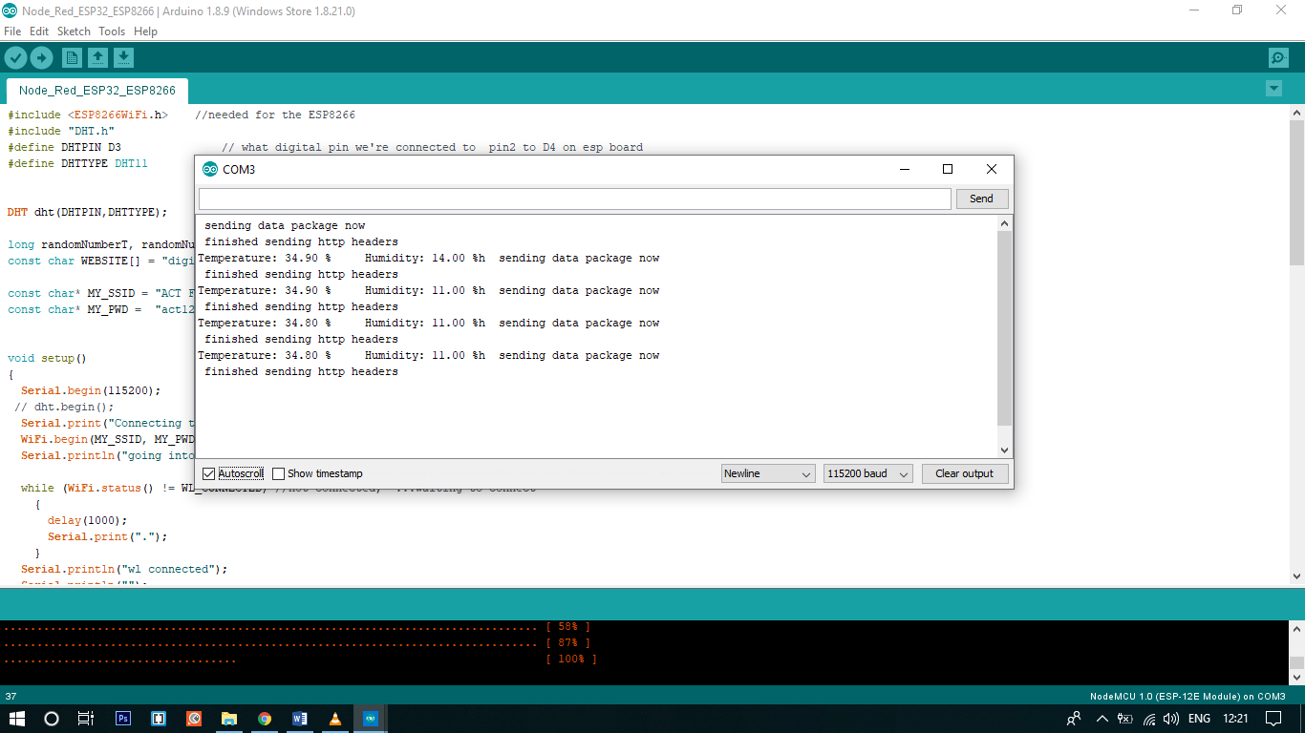

Now go to your DB2 database -> open console, then tap on Explore and go to your table and see the results.

